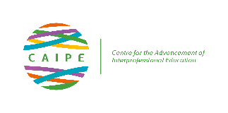

[Research] WORKING GROUP PROFORMA

WORKING GROUP NAME: | Research
GROUP LEAD: | Veronica O’Carroll & Melissa Owens
GROUP MEMBERS: | 21 members with representation from Qatar, Sri Lanka, Rwanda, Philippines, Ireland, England, Wales, Scotland.
BRIEF STRATEGIC STATEMENT
The research group aim:
- To enhance CAIPE’s excellent scholarly reputation
- To capture and disseminate CAIPE’s existing interprofessional scholarship activities
- To provide a more prominent role for research and evaluation across the CAIPE membership
PROPOSED ACHIEVEMENTS
- A database of CAIPE members who are PhD/MD/Prof Doc supervisors and external examiners has been created as a resource to help students to identify interprofessional research supervisors or for members to identify external examiners.

- The group are looking out for appropriate funding to help undertake a review of IPE in the UK and are also exploring national and international funding opportunities for other collaborative interprofessional research. Recent Advance HE funding application was unsuccessful.

- The group have created 3 sub-working groups who are working on bids they aim to submit to the National Institute for Health Research in 2022.
OUTCOMES
- Increased number of PhD studies with a focus on IPE undertaken by universities with CAIPE corporate membership
2. Secure funding for Review of IPE in UK and commence review
3. Secure funding for collaborative national and international research opportunities
TIMELINE
Outcome 1. To review March 2022
Outcome 2. To achieve by November 2021
Outcome 3. To achieve by March 2022

