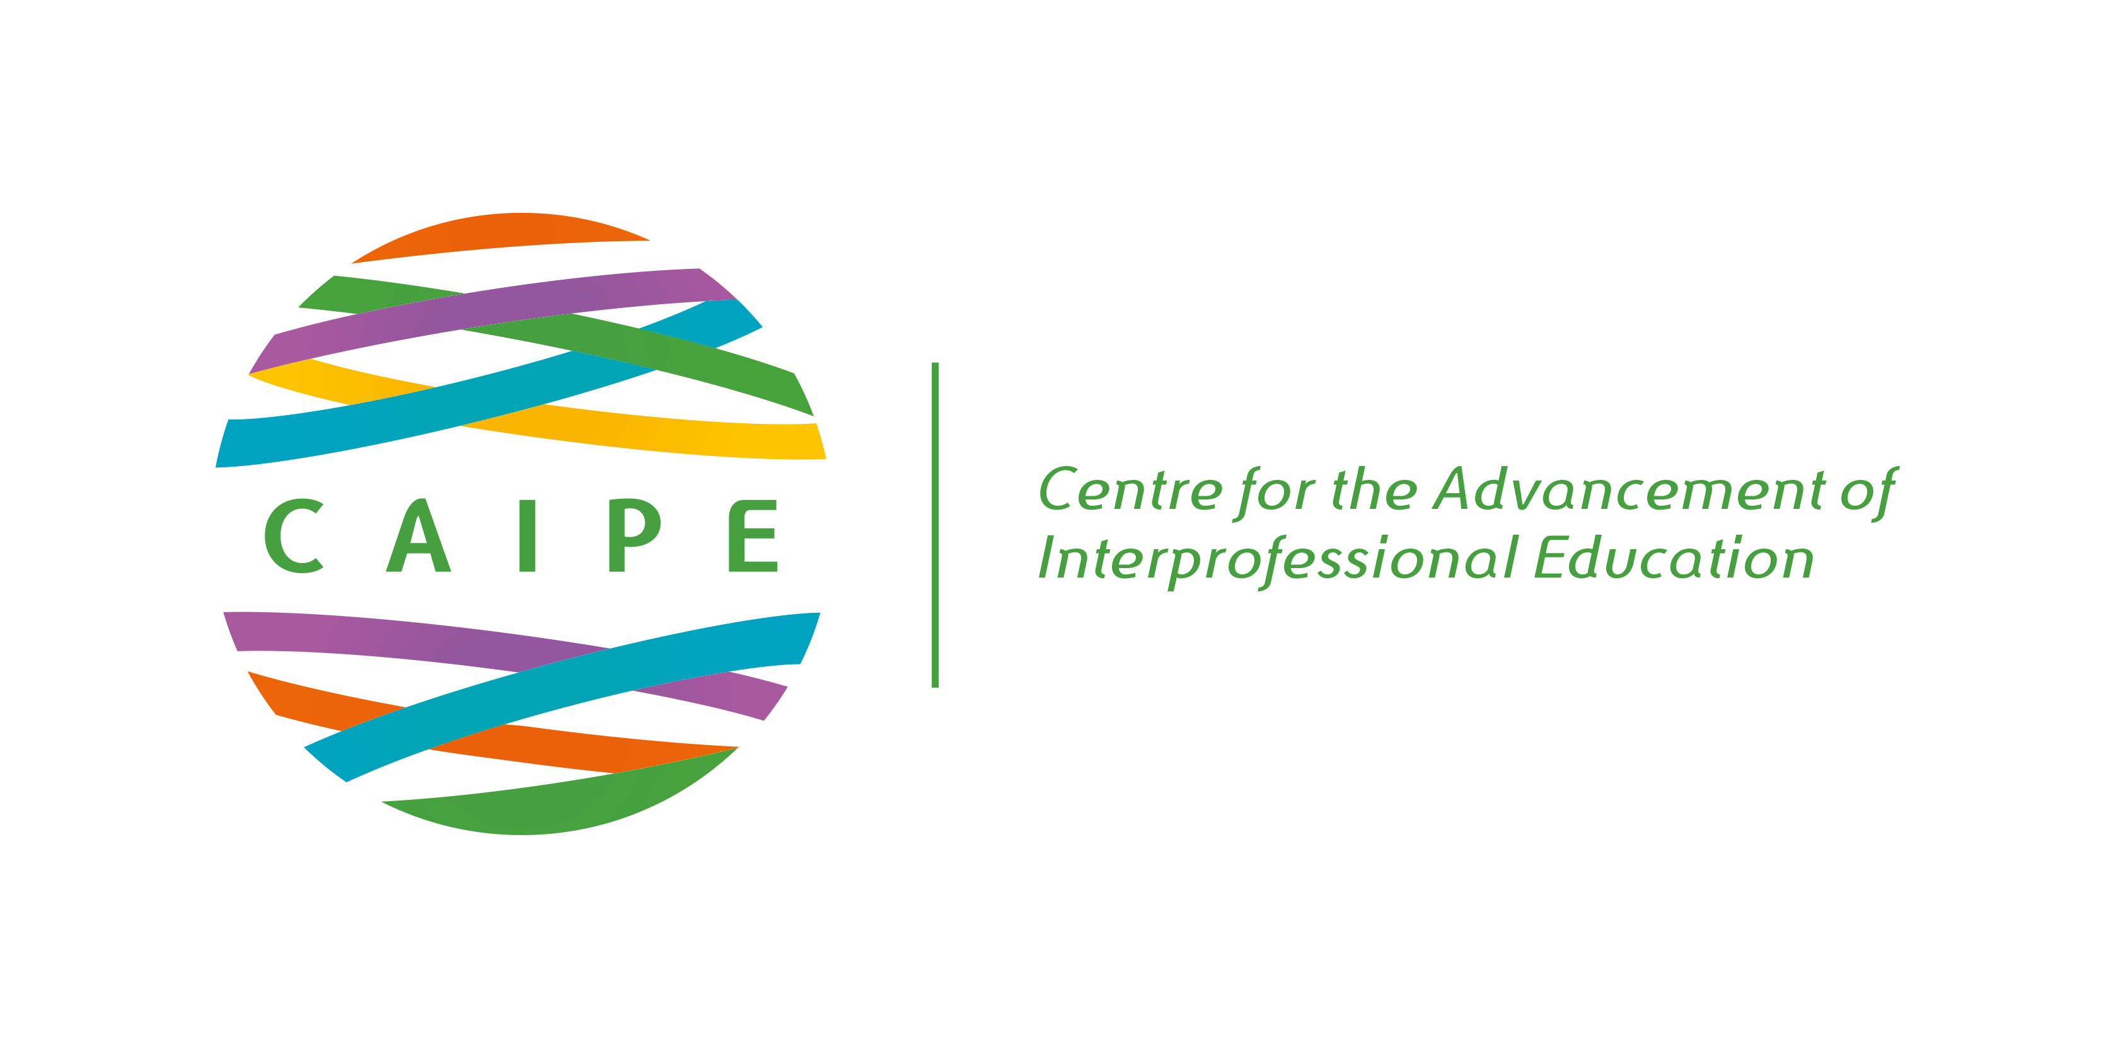

TASK GROUP PROFORMA

TASK GROUP NAME: | CAIPE International Liaison Group
GROUP LEAD: | Sundari Joseph
GROUP MEMBERS: | Juanjo Buenza, Amira Chaudrey, Alla El-Awaisi, Marion Huber, Michael Sy, Andreas Xyrichis, Sharon Buckley (now left) Steven Garvey (now left) Priya Martin (now left)
BRIEF STRATEGIC STATEMENT
The CAIPE International Liaison Group aims to……
• Promote and develop international interprofessional education and learning with the CAIPE membership
• Collaborate with like-minded individuals and organisations nationally and globally in interprofessional education, learning and practice
• Collaborate with International Stakeholders, Statutory, Professional and Regulatory Bodies in the promotion and development of IPE/IPL
• Act as a working group within the CAIPE board bringing international expertise to CAIPE
• Represent CAIPE as an international voice on IPE/IPL in both academia and the workplace.
• Provide information and advice to CAIPE members and visitors to the website on international perspectives through activities, publications, and workshops.
• Promote interest in CAIPE’s activities and membership through international networking
• Work with as representatives on working groups within International.Global
ACHIEVEMENTS in 2019-2021
- Creation of the international page for information on Covid-19 projects
The International page of CAIPE’s website has tried to capture the good work across the world in response to Covid-19. Many of us were overwhelmed with the response from communities and the collaborative working that we saw is something that has been yearned for by many of us in the interprofessional community. It has been an opportunity for sharing new learning, as we saw completely different approaches to transdisciplinary and interprofessional working, crossing boundaries and breaking down many stereotypes, ultimately achieving the greater outcomes for interprofessionalism!
We invited anyone from different countries to send us a short film clip (2min) and some text and photos that we can add to our Covid-19 special feature page https://www.caipe.org/covid-19
We hoped for a sharing of new knowledge and new working practices to care and support the most vulnerable in our communities during this pandemic.
Three film clips were received from UK; Sri Lanka and The Philippines.
- At one of our meetings an International Webinar was suggested. The plan was that group members could participate in developing an international webinar using Zoom The first one would be an introduction to the type of work we do - there could be 3-4 speakers from our group who would wish to do this. The audience from the first webinar could suggest what they would like to hear about for the 2nd webinar. This did not take place due to work pressures of the group and was superseded by CAIPE’s plans for the symposium.
- Promotion of the international component for the online CAIPE symposium in November 2020. A few members of the group participated in the delivery of the CAIPE symposium by acting as facilitators to introduce speakers and chair groupwork in the breakout rooms and also to present their work from the CAIPE research group.
OUTCOMES
Due to the COVID-19 pandemic and the group members work pressures meetings have been difficult. We also lost three members of the group within a short space of time.
We hope that the group can re-form and take forward some new and innovative objectives for 2021-2022.

